|  |  |  |
| --- | --- | --- |
| **Guide Name** | | **Panel Head** |
|  | Ramkumar Jayaraman | Dr .Jagadeesan S |
|  |  |  |
|  | **Faculty Advisor** | **Project Domain** |
|  | Dr Mathew Eliazer | Machine Learning and NLP |
| M |  |  |
|  | **Student(s) Details: Name** | **Passport size photo(s)** |
|  | 1. Madduri Namratha 2. K. Keerthana |  |
|  |  |  |



Registration Number(s)

1. RA2111003010240

2. RA2111003010250

**Email ID(s)&Mobile Number(s)**

|  |  |
| --- | --- |
| 1: mm1646@srmist.edu.in | 9515590367 |
| 2:kk4972@srmist.edu.in | 6379384697 |

**Abstract Architecture Diagram**

In the present generation, the social life of everyone has become associated with online social networks. These sites have made a drastic change in the way we pursue our social life. Making friends and keeping in contact with them and their updates has become easier. But with their rapid growth, many problems like fake profiles, online impersonation have also grown. There are no feasible solutions exist to control these problems. So we came up with a framework with which the automatic identification of fake profiles is possible and is efficient. This framework uses classification techniques such as support vector machine (SVM), Random forest classifier, Gradient boost classifier, Naïve bayes, and Logistic regression algorithm and Decision Tree classify the profiles into fake or genuine classes. In final prediction we will gain the values of accuracy, classification report and confusion matrix.

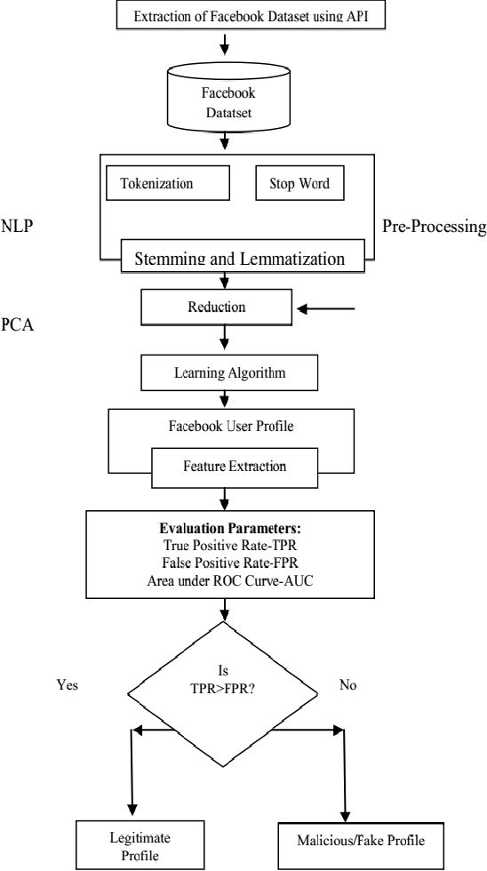

The detection of fake profiles using machine learning holds significant importance across various domains, including social media, e-commerce, cybersecurity, and online communities.

• **Preventing Cybercrime:** Fake profiles are often used for malicious purposes, including phishing, spreading malware, and conducting fraud. Machine learning helps in early detection and mitigation of these threats, protecting users from cyberattacks.

• **Identity Theft Prevention:** Detecting fake profiles helps in safeguarding personal information and reducing the risk of identity theft.

• **Social Media Integrity:** Fake profiles can manipulate opinions, spread misinformation, and skew social media trends. Detecting and removing these profiles helps maintain the authenticity and reliability of online platforms.

• **E-commerce Reliability:** In online marketplaces, fake profiles can lead to fraudulent transactions, false reviews, and scams. Machine learning models can help in identifying and removing these profiles, ensuring a safer shopping experience.

**Significance of the Project Conclusion**

The proposed project mainly focuses on how the machine learning algorithms such as support vector machine ,Random forest classifier,Gradient boost classifier,Naive Bates's ,logistic regression and Decision tree that can be leveraged for better insights exploration over a well distributed dataset .The proposed framework exhibits how different attributes with user activity can be learned or analysed by these algorithms to predict any suspicious activity and tells the probability of that specific account being fake or genuine one. Furthermore, this algorithm can be improved by scraping more metadata - like visual features - images, posts, captions, activity spend time and heavy Machine learning models can be ensemble to do the task.

**Conference/Journal Publication Details (Mandatory)**